MultiModal Authentication using Face and Speech
Abstract
This report gives a brief background about multi-model biometrics. A particular attention is given to face and speech recognition. Face recognition refers to an automated or semi-automated process of matching facial images. Many techniques are available to apply face recognition of which is Principle Component Analysis (PCA). PCA is a way of identifying patterns in data and expressing the data in such a way to highlight their similarities and differences. Before applying this method to face recognition, a brief introduction is given for PCA from mathematical point of view. The last part of the report gives an explanation about the implementation of PCA in C#.
Recognizing people is a multimodal and multifaceted process. In pathological conditions such as blindness or deafness, recognition can be accomplished by the sensory modalities that remain intact. If advanced processing stages for a single modality are impaired, as in prosopagnosia or phonagnosia, person identification is normally achieved by alternative features in the same modality, for example, biological motion patterns, or by other modalities.
To understand how we can use our face recognition system, a description of the Graphical User Interface is given.

BACKGROUND
Biometrics:
Biometrics is the automated recognition of individuals based on their behavioural or physiological characteristics .The physiological characteristics are related to the shape of the body. The most common example is fingerprint. Other examples include face recognition, hand geometry and iris recognition. The behavioural characteristics are related to the behaviour of a person. Signature is one example of these characteristics which is still widely used today. Modern approaches are the study of keystroke dynamics and voice.

Introduction
Humans have been using physical characteristics such as face, voice, gait, etc. to recognize each other for thousands of years. With new advances in technology, biometrics has become an emerging technology for recognizing individuals using their biological traits. Now, biometrics is becoming part of day to day life, where in a person is recognized by his/her personal biological characteristics. Examples of different Biometric systems include Fingerprint recognition, Face recognition, Iris recognition, Retina recognition, Hand geometry, Voice recognition, Signature recognition, among others. Face recognition, in particular has received a considerable attention in recent years both from the industry and the research community. The objective of our project is to create a C# code that can be used to identify people using their face images. This report gives a brief background about biometrics. A particular attention is given to face recognition. Face recognition refers to an automated or semi-automated process of matching facial images. Many techniques are available to apply face recognition of which is Principle Component Analysis (PCA). PCA is a way of identifying patterns in data and expressing the data in such a way to highlight their similarities and differences. Before applying this method to face recognition, a brief introduction is given for PCA from mathematical point of view. The last part of the report gives an explanation about the implementation of PCA in C#. To understand how we can use our face recognition system, a description of the Graphical User Interface is given.

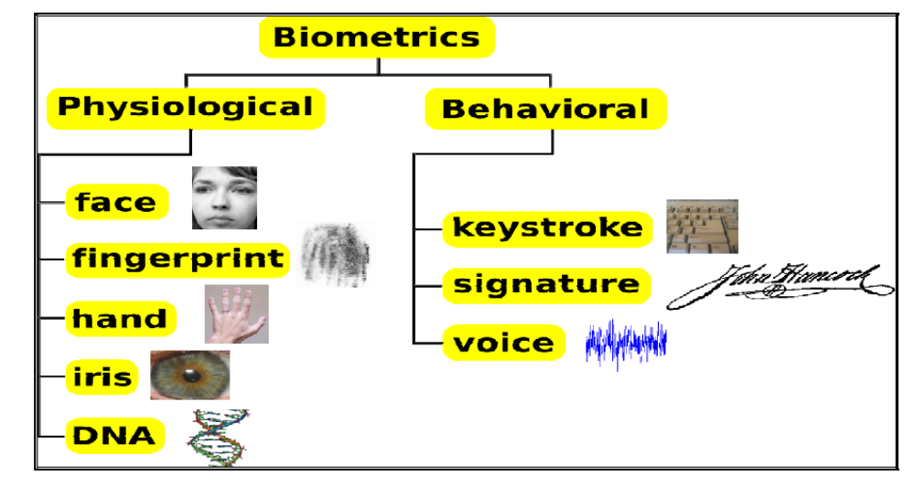
Figure 1: MultiModal Biometrics Types
Aims and Objective

The purpose of our project is to create an accurate and convenient way to implement recognition of human features using DSP. In this world filled with credit cards, driver’s licenses, bank accounts, and all sorts of other verification of identity, there are more and more venues in which ones’ identity can be stolen. The physical identifications can be lost or stolen, verification numbers can be forgotten, and even signatures can be forged. With our system of recognition, we are hoping to use the traits that are much more difficult to lose or be taken: voice and facial structures. This, in combination with password protection, will ensure that whatever is being protected will remain same. In addition, since this system relies on voice, speech, and face, it will eliminate the need to carry cards or memorize numbers.

2. Objectives
Our idea is to create an identification system where the user will speak into a microphone in front of a camera while pressing a key on the keyboard. The key will indicate that the user is currently speaking and will tell the DSP chip to record what the user says in addition to taking Visual. The user may say anything they would like, as the passwords will be pre programmed ahead of time through a training system. The analogue signals will be fed into the DSP board, where processing will compare the input to the known users. Then, if the speaker, password, and picture match up with a valid entry in the database, then the DSP chip will send the person’s ID number preset in the DSP chip to the FPGA, and the result (name, maybe picture) will be displayed on an LCD.
Benefits
• Eliminates the dependency on carrying identification
• Significant increase in security
• Great reduction in ability to duplicate passwords
• Uniqueness fundamentally a part of system due to differences between users
Features
• A key which puts the system into either training or testing mode
• A key which starts the recording of voice and speech
• Accuracy of at least 80%
• Advanced algorithm which combines results from voice, speech, and face features
• LCD display of matched user from database
Multi Modal Biometric Characteristics

A number of biometric characteristics exist and are in use in various applications, each biometric has its strengths and weaknesses, and the choice depends on the application. No single biometric is expected to effectively meet the requirements of all the applications. In other words, no biometric is optimal. Any human physiological and/or behavioural characteristic can be used as a biometric characteristic as long as it satisfies the following requirements:

- Universality: Each and every person throughout the world should have a biometric characteristic on the basis of which he/she could be represented, for example every person has a thumb impression which is unique with him.

- Distinctiveness: any two persons should be sufficiently different in terms of a biometric characteristic measure. Taking the above example any two persons will have different thumb impression.

- Collect-ability: the biometric characteristic can be measured quantitatively with an ease. For example taking a snap of face is typically easy with a camera, where as it is difficult to take a retina sample of a person, but it is possible.

- Permanence: the characteristic should be sufficiently invariant (with respect to the matching criterion) over a period of time. Taking an example of face recognition as a person grows in age his or her face changes over a time.

- Performance: It refers to the achievable recognition accuracy and speed, the resources required to achieve the desired recognition accuracy and speed, as well as the operational and environmental factors that affect the accuracy and speed.

- Acceptability: It indicates the extent to which people are willing to accept the use of a particular biometric identifier (characteristic) in their daily lives.

- Circumvention: It reflects how easily the system can be fooled using fraudulent methods or could be avoided. For example in voice recognition any person’s voice can be recorded and the biometric system can easily be fooled.
Well Known Multi Modal Biometrics Characteristics:

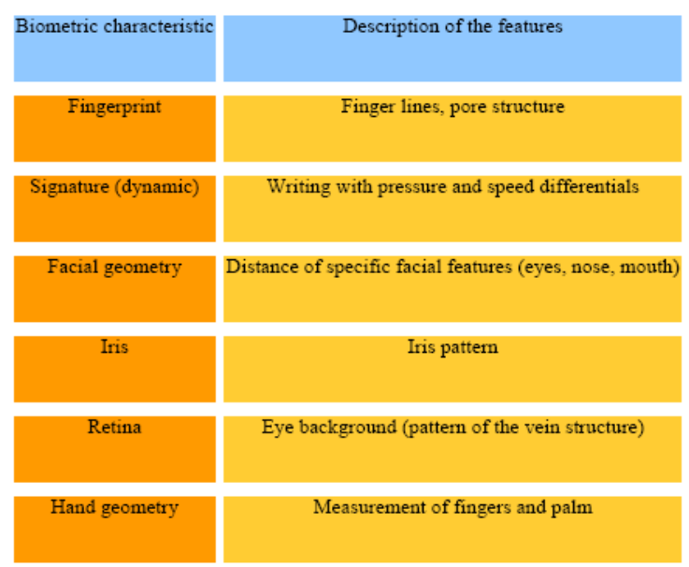
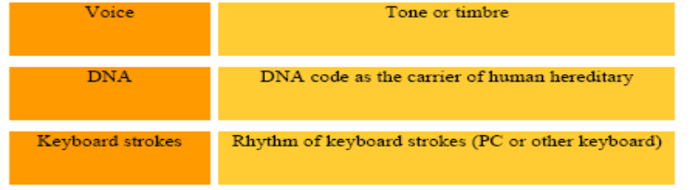

Applications of Biometrics:

The applications of biometrics can be divided into the following three main groups:
- Commercial applications: such as computer network login, electronic data security, e-commerce, Internet access, ATM, credit card, physical access control, cellular phone, PDA, medical records management, distance learning, etc.

- Government applications: such as national ID card, correctional facility, driver’s license, social security, welfare-disbursement, border control, passport control, etc

- Forensic applications: such as corpse identification, criminal investigation, terrorist identification, parenthood determination, missing children, etc can be carried out using biometric systems.

Face Recognition Process

There are four steps in face recognition process:

- Acquiring a sample: In a complete, full implemented biometric system, a sensor takes an observation. The sensor might be a camera and the observation is a snapshot picture. In our system, a sensor will be ignored, and a 2D face picture “observation” will supplied manually.
- Extracting Features: For this step, the relevant data is extracted from the predefined captured sample. This is can be done by the use of software where many algorithms are available. The outcome of this step is a biometric template which is a reduced set of data that represents the unique features of the enrolled user's face.

- Comparison Templates: This depends on the application at hand. For identification purposes, this step will be a comparison between a given picture for the subject and all the biometric templates stored on a database. For verification, the biometric template of the claimed identity will be retrieved (either from a database or a storage medium presented by the subject) and this will be compared to a given picture.

- Declaring a Match: The face recognition system will return a candidate match list of potential matches. In this case, the intervention of a human operator will be required in order to select the best fit from the candidate list. An illustrative analogy is that of a walk-through metal detector, where if a person causes the 7 detector to beep, a human operator steps in and checks the person manually or with a hand-held detector.

Face Recognition Techniques:

All available face recognition techniques can be classified into four categories based on the way they represent face;
- Appearance based which uses holistic texture features.

- Model based which employ shape and texture of the face, along with 3D depth
information.

- Template based face recognition.

- Techniques using Neural Networks.

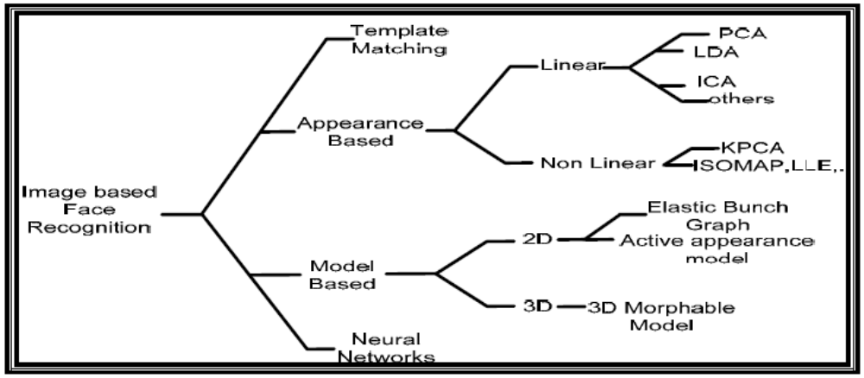Classification of face recognition method

Speech Recognition process
Speech recognition basically means talking to a computer, having it recognize what we
are saying, and lastly, doing this in real time. This process fundamentally functions as a
pipeline that converts PCM (Pulse Code Modulation) digital audio from a sound card into
recognized speech. The elements of the pipeline are:

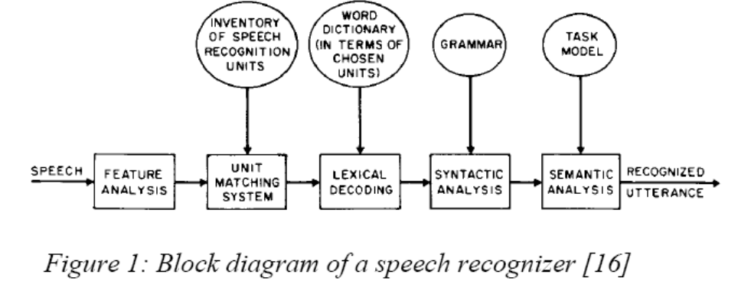

Transform the PCM digital audio into a better acoustic representation – The input to speech recognizer is in the form of a stream of amplitudes, sampled at about 16,000 times per second. But audio in this form is not useful for the recognizer. Hence, Fast-Fourier transformations are used to produce graphs of frequency components describing the sound heard for 1/100th of a second. Any sound is then identified by matching it to its closest entry in the database of such graphs, producing a number, called the “feature number” that describes the sound.

- Unit matching system: provides likelihoods of a match of all sequences of speech recognition units to the input speech. These units may be phones, diphones, syllables or derivative units such as fenones and acoustic units. They may also be whole word units or units corresponding to group of 2 or more words. Each such unit is characterized by some HMM whose parameters are estimated through a training set of speech data.
- Lexical Decoding constraints the unit matching system to follow only those search paths sequences whose speech units are present in a word dictionary.
- Apply a "grammar" so the speech recognizer knows what phonemes to expect. This further places constraints on the search sequence of unit matching system. A grammar could be anything from a context-free grammar to full-blown English.
- Figure out which phonemes are spoken – This is a quite dicey task as different words sound differently as spoken by different persons. Also, background noises from microphone make the recognizer hear a different vector. Thus a probability analysis is done during recognition. A hypothesis is formed based on this analysis. A speech recognizer works by hypothesizing a number of different "states" at once. Each state contains a phoneme with a history of previous phonemes. The hypothesized state with the highest score is used as the final recognition result.

Now that we've discussed some of the basic terms and concepts involved in speech recognition, let's put them together and take a look at how the speech recognition process works.
As you can probably imagine, the speech recognition engine has a rather complex task to handle, that of taking raw audio input and translating it to recognized text that an application understands. As shown in the diagram below, the major components we want to discuss are:

- • Audio input

- • Grammar(s)

- • Acoustic Model

- • Recognized text

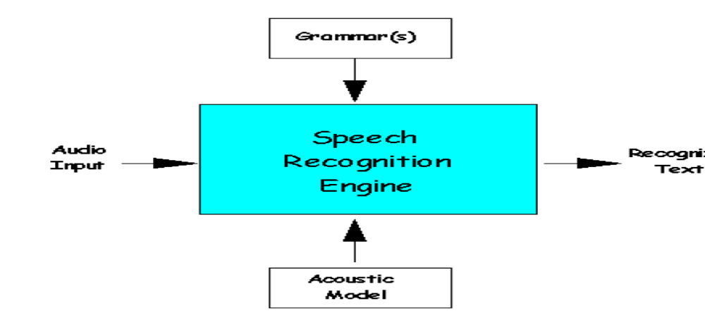

The first thing we want to take a look at is the audio input coming into the recognition engine. It is important to understand that this audio stream is rarely pristine. It contains not only the speech data (what was said) but also background noise. This noise can interfere with the recognition process, and the speech engine must handle (and possibly even adapt to) the environment within which the audio is spoken.
As we've discussed, it is the job of the speech recognition engine to convert spoken input into text. To do this, it employs all sorts of data, statistics, and software algorithms. Its first job is to process the incoming audio signal and convert it into a format best suited for further analysis. Once the speech data is in the proper format, the engine searches for the best match.
It does this by taking into consideration the words and phrases it knows about (the active grammars), along with its knowledge of the environment in which it is operating (for VoiceXML, this is the telephony environment). The knowledge of the environment is provided in the form of an acoustic model. Once it identifies the the most likely match for what was said, it returns what it recognized as a text string. Most speech engines try very hard to find a match, and are usually very "forgiving." But it is important to note that the engine is always returning it's best guess for what was said.

Acceptance and Rejection:

When the recognition engine processes an utterance, it returns a result. The result can be either of two states: acceptance or rejection. An accepted utterance is one in which the engine returns recognized text.
Whatever the caller says, the speech recognition engine tries very hard to match the utterance to a word or phrase in the active grammar. Sometimes the match may be poor because the caller said something that the application was not expecting, or the caller spoke indistinctly In these case, the speech engine returns the closest match, which might be incorrect. Some engines also return a confidence score along with the text to indicate the likelihood that the returned text is correct. Not all utterances that are processed by the speech engine are accepted. Acceptance or rejection is flagged by the engine with each processed utterance.

PRINCIPLE COMPONENT ANALYSIS (PCA)

PCA is a way of identifying patterns in data and expressing the data in such a way to highlight their similarities and differences [6]. The purpose of PCA is to reduce the large dimensionality of the data space (observed variables) to smaller intrinsic dimensionality of feature space (independent variables) which are needed to describe the data economically.

Mathematical Theory

To perform a PCA on a set of data, the following steps are needed:
Step 1: Get some data.
Step 2: Subtract the mean: take the average across each dimension. This produces a data set whose mean is zero.
Step 3: calculate the covariance matrix.
The aim of finding the covariance is to see if there is any relationship between the data dimensions. Covariance is always measured between two dimensions matrix. If we have a data set with more than one matrix of dimensions 2, there result are more than one covariance measurements that can be calculated. The most practical way to get all the possible covariance values between the different dimensions is to calculate them all and put them in one big 2D matrix. The definition for the covariance matrix for a set of data with n dimensions is:



Validating Voice Recognition / Face Recognition

In order to verify that voice and face recognition are functioning correctly, multiple users who are in the database as well as those who are not will need to test the system. The training library and recognition algorithms will also be modified as needed. One note is that we must make sure that the system rejects the users who are not in the database. When testing the algorithms that we will be using for feature extraction and classification, we will use a confusion matrix to determine the likeliness that a certain input sample is one of the users. In this matrix, the columns will represent what was detected, and the rows will represent the actual user. For example:
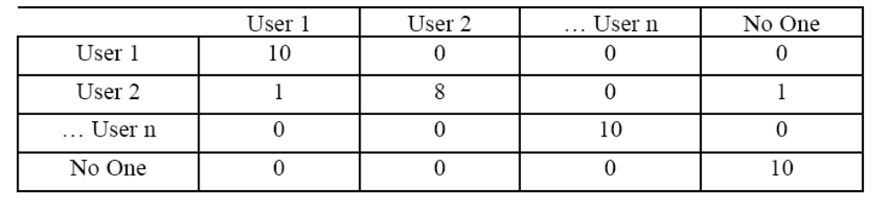

In this figure, there were 10 samples from each user who were in the database, as well as 10 from those who are not. User 1 was correctly identified every time, while user 2 was mistakenly identified as user 1 once and as not in the database once. With a good algorithm, our goal is to make this matrix s*I where s is the number of samples from each user, and I is the n-by-n identity matrix, where n is the number of users.

PROJECT REQUIREMENTS

4.1 Glossary of the Technical Terms
Term Definition 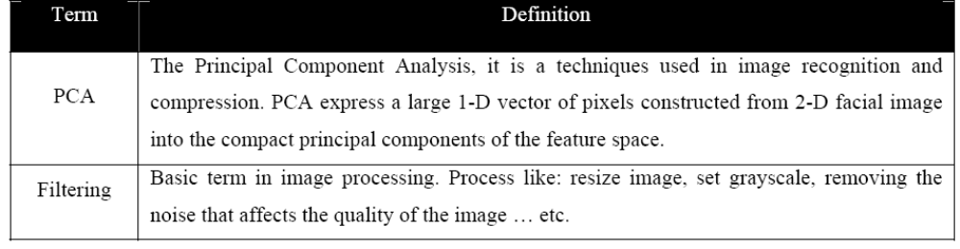

4.2 User Requirements

1. Functional requirements
a. The user should be able to enter records.
b. Each record represents information about a person and contains an image of his/her face.
c. Records may consist of:
i. First name.
ii. Last name.
iii. Phone.
iv. Address (city-street address).
v. Face image(s).
vi. ID-number.
vii. User -Speech
d. The system must be able to take face image as an input and search for a matching face in the database, and then show the results.
e. The results should be viewed by showing the faces matches the input, and display the most possible image first, in numerical order.
f. The user should be able to chose (click on) the result that he/she wants and view the full record’s information of the person.
g. The system can do noisy filter on images.

2. Non Functional Requirements
a. Records are maintained in a database.
b. Every record shall be allocated a unique identifier (id-number).
c. User should be able to retrieve data by entering id or name.
d. The system should provide a control for the user over the result. Means, the system mustn’t decide what the right match is. Instead, the system should display records above 60% match.
e. The results may be shown on a box where it has scroll bar activated when the space of the box is not enough.
f. In a case the user choose to show all result, the system should show N-item in a box, where the user can forward to get next result.
g. The system should be able to handle images of all formats.
h. The images should be pre-processed by ignoring the irrelevant parts, means localizing and normalize the face.
i. The face should be localized by detecting inner and outer boundaries, background must be ignored.
j. To improve the performance, the database should include a transformed image (template) by PCA algorithm for each record, i.e. the template should be ready when it’s needed.
k. The database should be developed using Microsoft SQL Server.

SYSTEM ARCHITECTURE
S
Display Result
Apply PCA Algorithm/Speech Recognition Engine
Process with the Information Information
Fed Image/Voice
Start Application

System Process
- Acquiring a sample.
- In this step, the system fed with a 2D image by the system user along with the Voice of the User.
- Extracting Features
- For this step, the relevant data is extracted from the sample. This is can be done by using software where many algorithms are available, e.g. matlab library. The outcome of this step is a biometric template which is a reduced set of data that represents the unique features of the enrolled user's face.
- Comparison Templates.
- This depends on the application at hand. For identification purposes, this step will be a comparison between the biometric template captured from the subject at that moment and all the biometric templates stored on a database. For verification, the biometric template of the claimed identity will be retrieved (either from a database or a storage medium presented by the subject) and this will be compared to the biometric data captured at that moment.
- Declaring a Match
- The face and Voice recognition system will either return a match or a candidate list of potential matches. In the second case, the intervention of a human operator will be required in order to select the best fit from the candidate list. An illustrative analogy is that of a walk-through metal detector, where if a person causes the detector to beep, a human operator steps in and checks the person manually or with a hand-held detector.

Design Rationale

1. It runs smoothly on machine.
2. Easy for management.
3. Easy to learn.

Architectural Description

1. Application Interface:
2. It’s on top of the System and provides a graphical front end to the system.
3. Matcher:
4. It provides the algorithms and image processing needed to test if a match exists. In addition to the classes and functions needed to communicate with the Database.
5. Template Generator:
6. It holds the PCA algorithm and all libraries need to generate the Eigenface from the face images. Egienfaces are a large set of digitized images of human faces, taken under the same lighting conditions. Those images are normalized to line up the eyes and mouths. They are then all resample at the same pixel resolution. Egienfaces can be extracted out of the image data by mean of mathematical tool called principal component analysis.
7. Template Database:
8. It contains of two tables, one for the Eigenface template + face images and the second for personal information related to his/her face image.

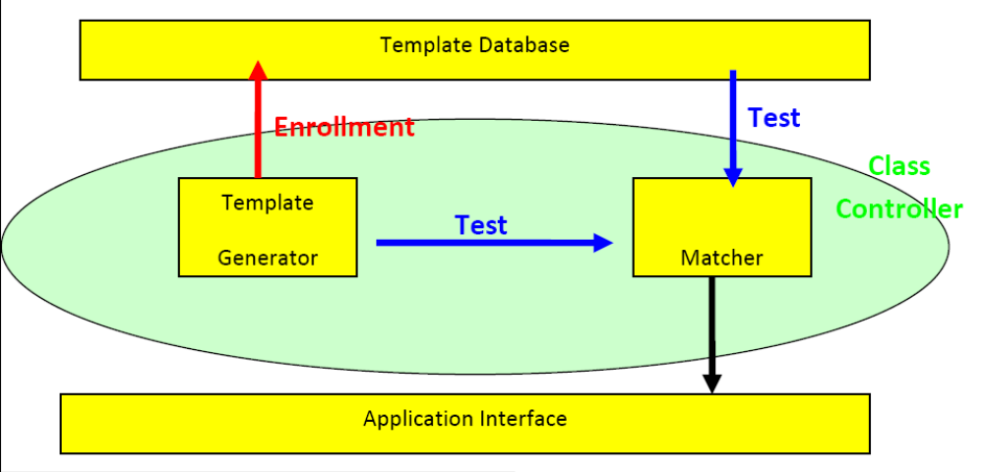
Deployment Architecture

SYSTEM EVALUATION

Tests and Results
In order to investigate the accuracy of our code, a set of accuracy test was performed. It’s noticed that if we increase the number of training, the accuracy increases. Also, it’s noticed the relation is positive correlation between the number of training images taken for a person and the accuracy. As we increase the training images for a person, the accuracy increases.

Observation

During our test, we remark some undesirable conditions that must be take care of to get the best result. We notice that, uncontrolled environmental condition; to ensure the best result, the image must strip out of its background, or all training set must have a unique background color. Also, must have the same dimensions size and the same color. We enforce out training set to be 50x50 in, and to have a gray scale color, all this will be take care of it automatically. Another notice is uncooperative subject condition; we notice the subject must look forward to get the best result. In addition, the result will be effected if the subject wearing glasses, having facial hair, or having an unusual expression.

RECOMMENDATIONS

At the end of this project we learn the basic idea of face recognition system. We discover some the points that affect the operation of the system. So, we recommend the following in order to get an efficient system.
- Use a high quality image with no background.
- Take a sufficient number of training images for a person. The specific number depends on the total number of the people in the database. As people increases, we have to take more training pictures.
- Provide a good location to take pictures and utilize the face detection.
- Investigate parameters that affect the performance of the code like the distance measures.

Technical Requirements

HARDWARE
- 1.66 GHz Pentium Processor or Intel compatible processor.
- 2GB RAM.
- 80 GB free hard disk space.
- Web Camera

SOFTWARE
- Visual Studio 2008(.Net framework)
- Matlab
- MS SQL Server 2005

mmmmmmmm
MouMModu

